# INTERACTIVE ANIMATOR

## Initial State: Transmission delay versus propagation delay

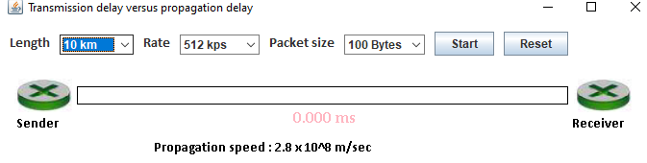

1. **Start: Length = 10km, Rate = 512 kps, Packet Size = 100 Bytes**

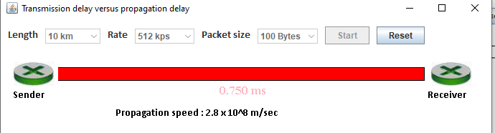

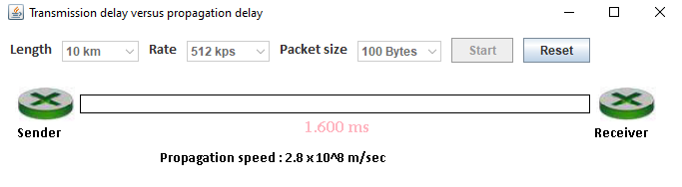

**2. Length = 100km, Rate = 512 kps, Packet Size = 100 Bytes**

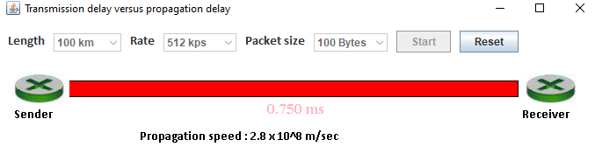

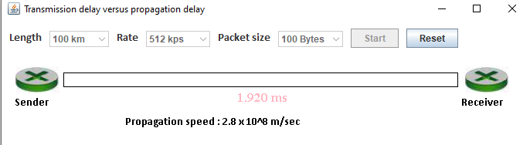

1. **Length = 500km, Rate = 512 kps, Packet size = 100 Bytes**

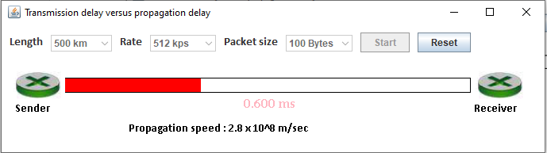

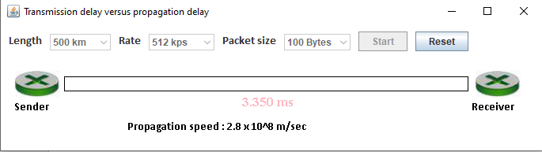

**4. Length = 1000km, Rate = 512 kps, Packet size = 100 Bytes**

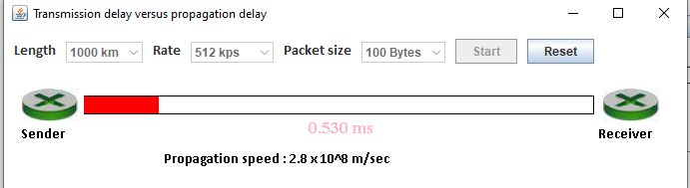

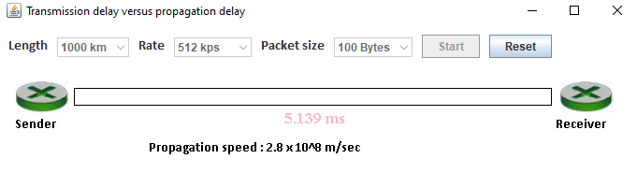

The red color on the link indicates the movement of data packets as the timer continues to count from the beginning till the end of the transmission.